Yuwen Sang

COMP 3421 Exercise Week 8 – Part 2

**Step A) Use mongo interactive mode**

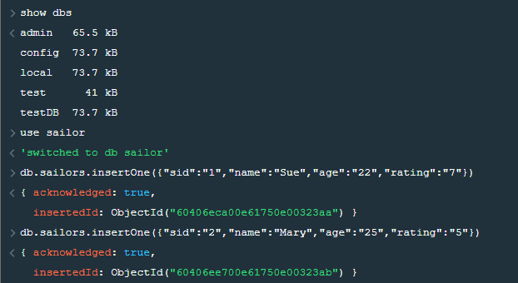

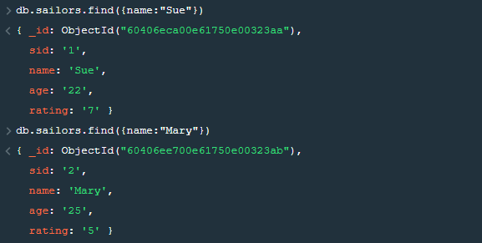

**Step B) Use pymongo**

**Code:**

|  |
| --- |
| import pymongo  import pprint  from pymongo import MongoClient  client = MongoClient() #connects on default host  #Creating  db = client.testDB  sailor1 = {"sid":"1","name":"Sue","age":"22","rating":"7"}  sailor2 = {"sid":"2","name":"Mary","age":"25","rating":"5"}  peeps = db.sailors # think of this as "create table", but no need to specifying fields!  peep_id = peeps.insert_one(sailor1).inserted_id  print("\nid returned from insert:" + str(peep_id))  peep_id = peeps.insert_one(sailor2).inserted_id  print("\nid returned from insert:" + str(peep_id))  print("\nOutput from peeps.find():")  for objs in peeps.find():  pprint.pprint(objs) |

**Output:**

